LAB 9
Task 1:
BEGIN;
DELETE FROM baggage_check WHERE booking_id = 10; DELETE FROM baggage WHERE booking_id = 10;
DELETE FROM booking WHERE booking_id = 10;
DELETE FROM booking WHERE booking_id = -1;
ROLLBACK;
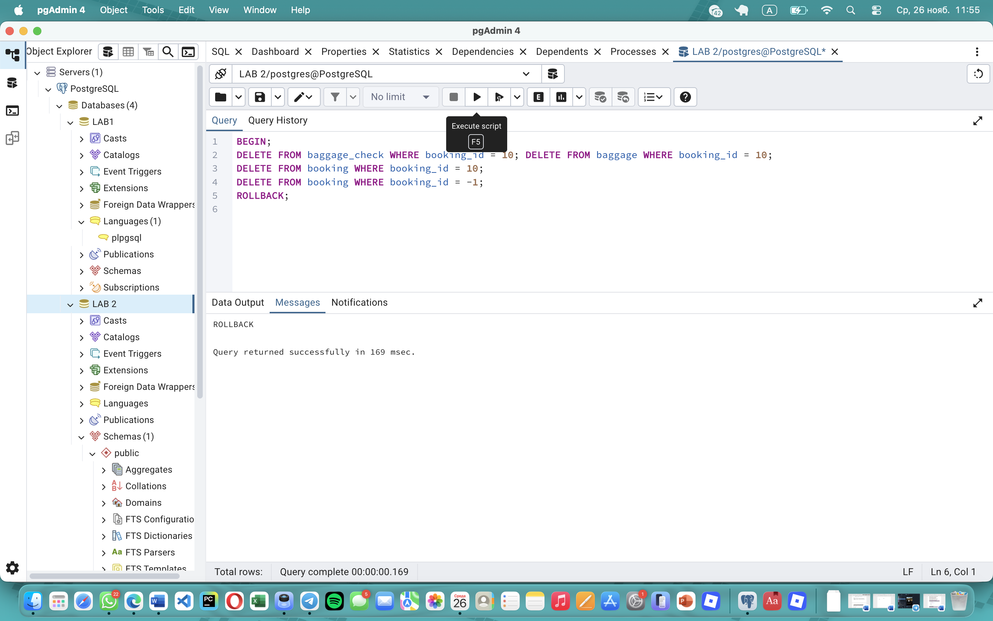
Task 2:
BEGIN;
UPDATE flights
SET sch_departure_time = '2025-01-30 14:00:00'
WHERE flight_id = 5; -- Error simulation UPDATE flights SET sch_departure_time = '2025-01-30 15:00:00' WHERE flight_id = -1; ROLLBACK;
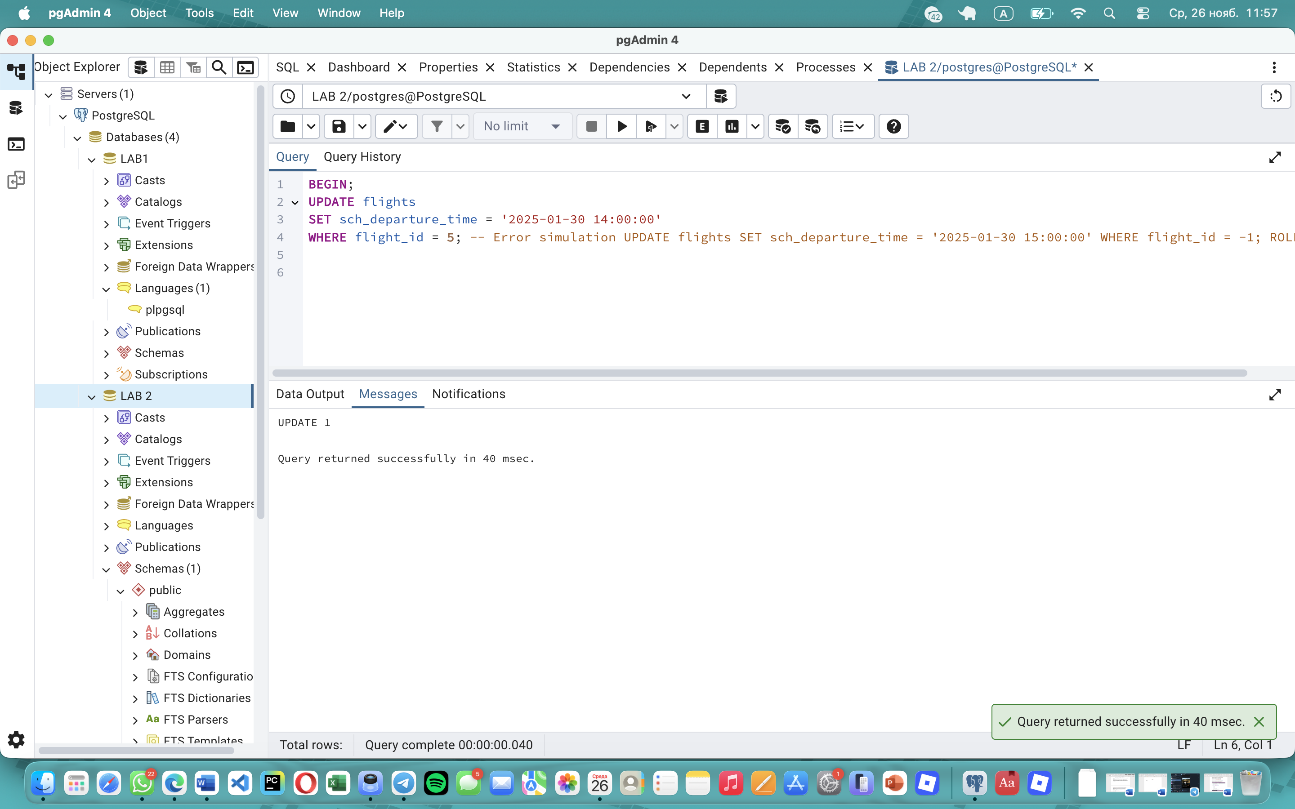
Task 3:
BEGIN;
UPDATE tickets
SET price = price - 50 WHERE flight_number = 'SU1002'; -- Error simulation
UPDATE tickets SET price = price / 0; ROLLBACK;
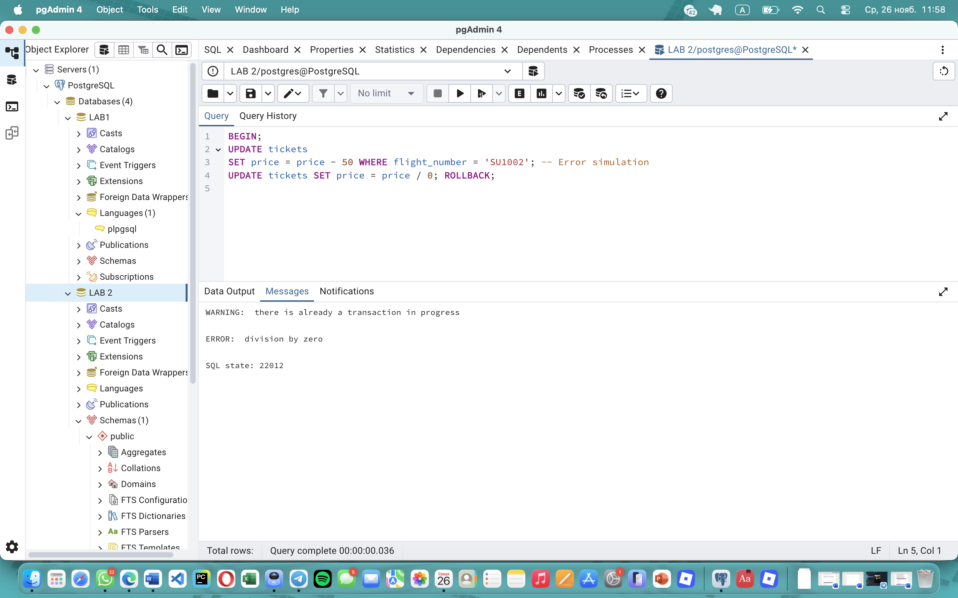
Task 4:
BEGIN;
UPDATE passengers SET first_name = 'John', last_name = 'Williams', country_of_citizenship = 'USA' WHERE passenger_id = 12;
UPDATE booking SET passenger_id = 12 WHERE passenger_id = 12; -- Error simulation
UPDATE passengers SET first_name = NULL WHERE passenger_id = -1;
ROLLBACK;
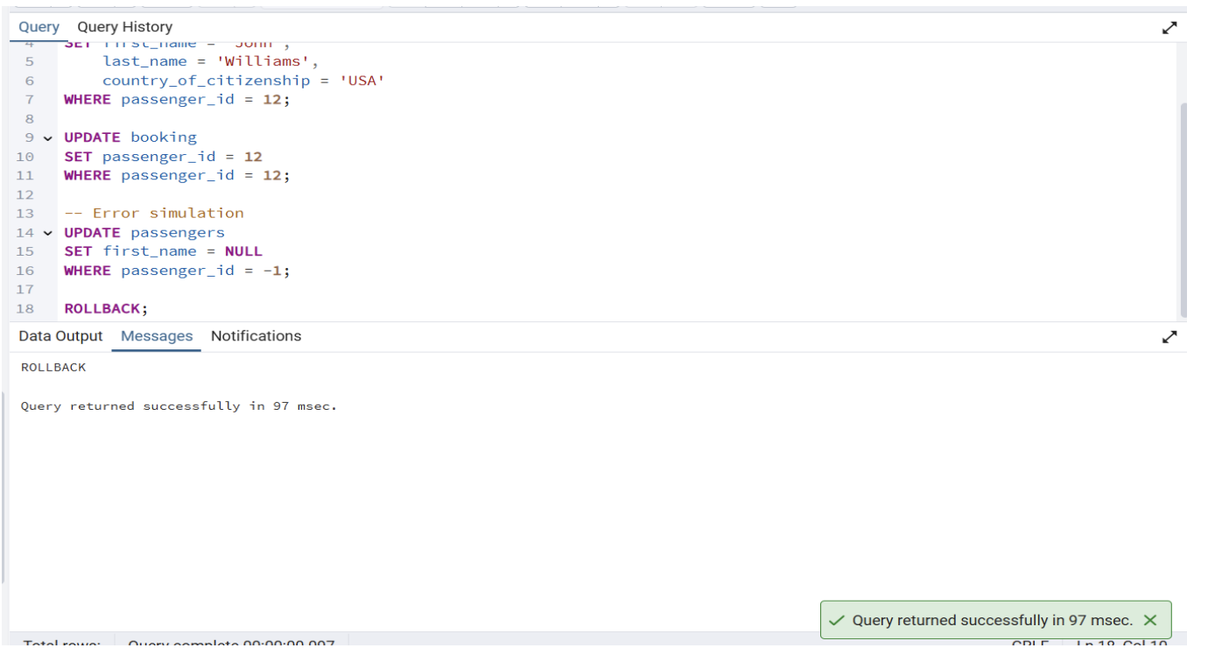
Task 5:
BEGIN;
INSERT INTO passengers (first_name, last_name, country_of_citizenship, date_of_birth, passport_number, gender,passenger_id, country_of_residence, created_at, updated_at )
VALUES ('Adam', 'Stone', 'Canada', '1990-01-01', 'AB1234567', 'M', '99', 'India', NOW(), NOW()) RETURNING passenger_id;
INSERT INTO booking ( booking_id, passenger_id, booking_platform, flight_id, created_at, updated_at, status, ticket_price, ticket_discount)
VALUES ( 1001, 5, 'Mobile App', 2003, NOW(), NOW(), 'Co', 0, 0 ); ROLLBACK; COMMIT;
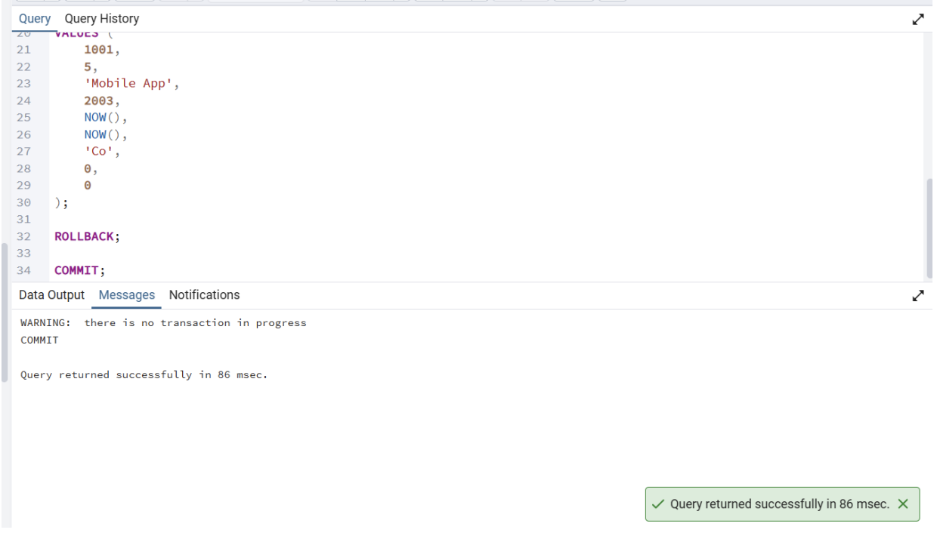
Task 6:
BEGIN;
UPDATE tickets SET price = price + 30 WHERE flight_number = 'SU1004';
ROLLBACK;
COMMIT;
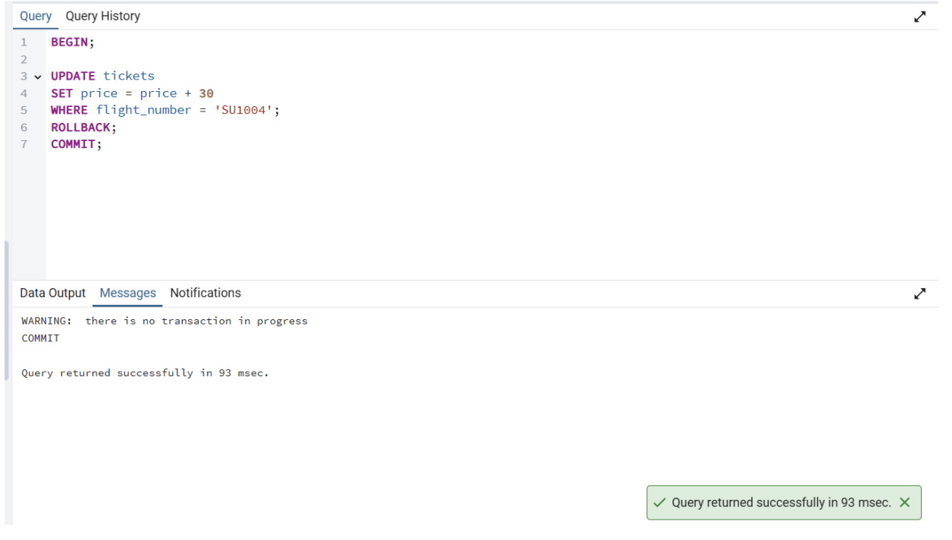
Task 7:
BEGIN;
UPDATE baggage SET weight_in_kg = 23.5
WHERE baggage_id = 77; -- Error simulation UPDATE baggage SET weight_in_kg = -5 WHERE baggage_id = 77;
ROLLBACK; -- COMMIT;
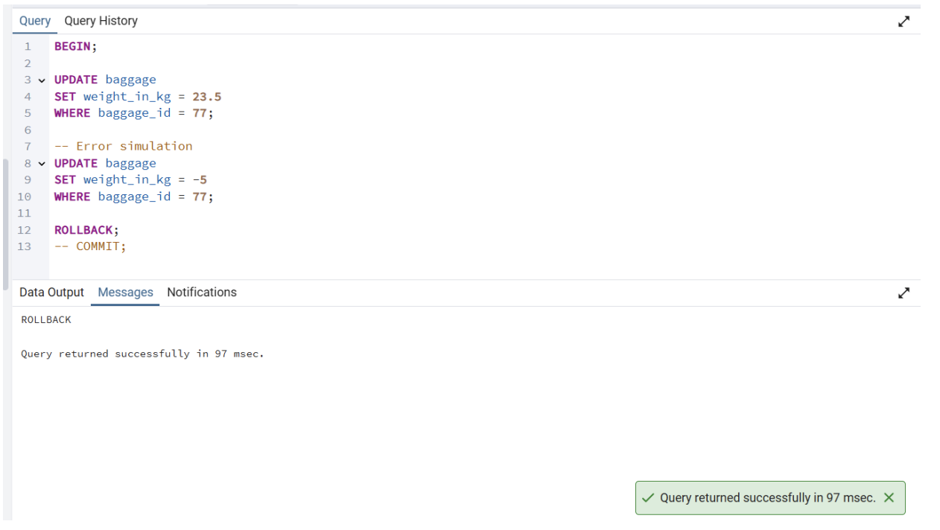
Task 8:
BEGIN;
UPDATE booking SET ticket_price = ticket_price * 0.85
WHERE booking_id = 300; -- Error simulation
UPDATE booking SET ticket_price = ticket_price / 0;
ROLLBACK; -- COMMIT;
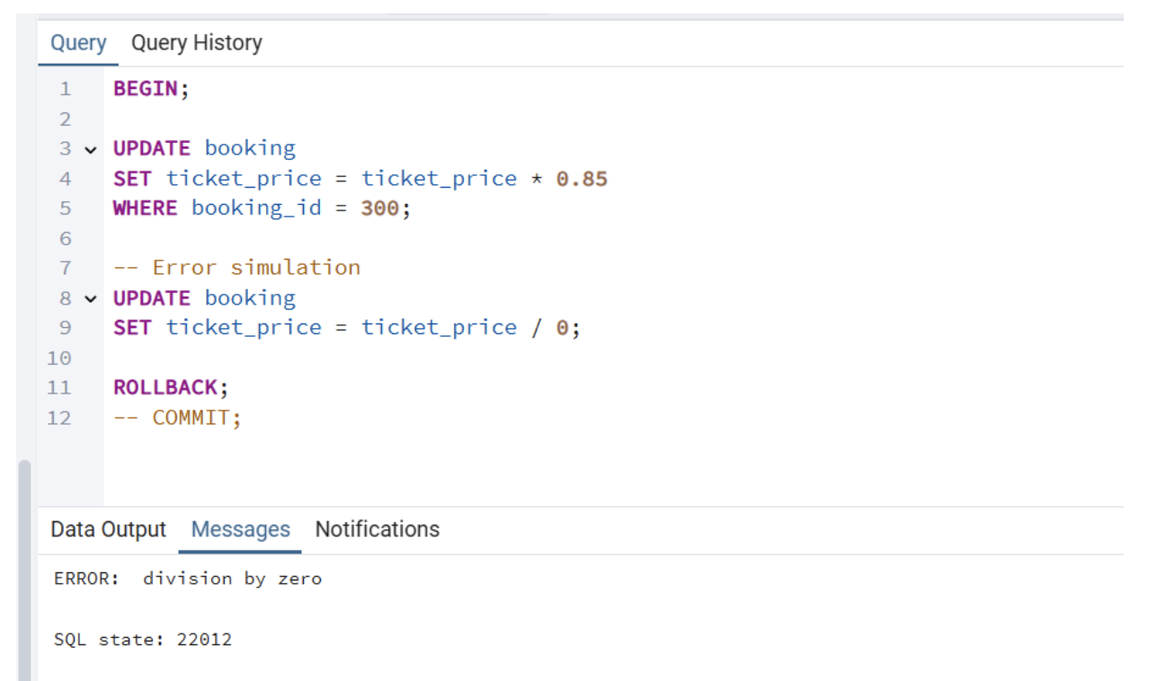
Task 9:
BEGIN;
UPDATE tickets SET flight_number = 'SU1001'
WHERE flight_number = 'SU1005'; -- Error simulation
UPDATE flights SET sch_departure_time = NULL WHERE flight_id = -1;
ROLLBACK; -- COMMIT;
